

Use Case Specification: eCL Employee Feed
For

eCoaching Log

Change History Log

Date | Version | Description | Author
01/26/2015 | 1.0 | Initial Document | Doug Stearns
01/28/2015 | 1.1 | P14072 – eCL EA Inactivations  Updates from review  Added new 3.10, 3.11, renumbered rest  Modified 4.1.1, 4.3.1, 4.4.1  Figure 1 | Doug Stearns
04/07/2016 | 1.2 | TFS2332 – eCL HR Access Solution  Updated 3.34 through 3.50  Figure 1 | Doug Stearns

Table of Contents

1. Brief Description 6
2. Participating Actors 6
2.1 Primary 6
3. Basic Flow of Events 7
3.1 System process executes at the scheduled time. 7
3.2 Aspect employee data file is access from appropriate folder. 7
3.3 Employee information is read from input file. 7
3.4 Input file EMP_ID assigned to EmpID_To_SupID_Stage.Emp_ID. 7
3.5 Input file EMP_SORT_NAME assigned to EmpID_To_SupID_Stage.Emp_Name. 7
3.6 Input file EMP_CLASS_1 assigned to EmpID_To_SupID_Stage.Emp_Program. 7
3.7 Input file EMP_CLASS_3 assigned to EmpID_To_SupID_Stage.Emp_Site. 7
3.8 Input file EMP_EXTRA_3 assigned to EmpID_To_SupID_Stage.Sup_ID. 7
3.9 Input file EMP_EXTRA_4 assigned to EmpID_To_SupID_Stage.Emp_Job_Code. 7
3.10 Input file EMP_CLASS_2 assigned to EmpID_To_SupID_Stage.Emp_Status. 7
3.11 Input file EMP_EXTRA_8 assigned to EmpID_To_SupID_Stage.Emp_LanID. 7
3.12 Employee id to supervisor id information is staged. 7
3.13 PeopleSoft employee data file is accessed from appropriate folder. 7
3.14 Employee information is read from input file. 7
3.15 Input file lanid assigned to Employee_Hierarchy_Stage.Emp_LanID. 7
3.16 Input file emplid assigned to Employee_Hierarchy_Stage.Emp_ID. 7
3.17 Input file last_name, first_name middle_name concatenated and assigned to Employee_Hierarchy_Stage.Emp_Name. 7
3.18 Input file location assigned to Employee_Hierarchy_Stage.Emp_Site. 7
3.19 Input file supervisorid assigned to Employee_Hierarchy_Stage.Emp_Sup_ID. 7
3.20 Input file managerid assigned to Employee_Hierarchy_Stage.Emp_Mgr_ID. 7
3.21 Input file jobcodeid assigned to Employee_Hierarchy_Stage.Emp_Job_Code. 7
3.22 Input file jobcode assigned to Employee_Hierarchy_Stage.Emp_Job_Description. 7
3.23 Input file email_addr assigned to Employee_Hierarchy_Stage.Emp_Email. 7
3.24 Input file empl_status assigned to Employee_Hierarchy_Stage.Active. 7
3.25 Input file last_hire_dt assigned to Employee_Hierarchy_Stage.Start_Date. 7
3.26 Employee hierarchy information is staged. 7
3.27 Employee hierarchy information is updated or populated from staged data. 7
3.28 Active status is updated. 7
3.29 CSR hierarchy information is updated or populated. 8
3.30 Coaching logs for migrated users updated. 8
3.31 Employee ID to LAN ID information is updated or populated. 8
3.32 Warning logs reviewed. 8
3.33 Employee information is updated. 8
3.34 PeopleSoft employee data file for HR employees is accessed from appropriate folder. 8
3.35 HR Employee information is read from input file. 8
3.36 Input file Emp_ID assigned to Employee_Hierarchy_Stage.Emp_ID. 8
3.37 Input file Emp_LandID assigned to Employee_Hierarchy_Stage.Emp_LanID. 8
3.38 Input file Emp_Name, assigned to Employee_Hierarchy_Stage.Emp_Name. 8
3.39 Input file Emp_Site assigned to Employee_Hierarchy_Stage.Emp_Site. 8
3.40 Input file Emp_Email assigned to Employee_Hierarchy_Stage.Emp_Email. 8
3.41 Input file Emp_Job_Code assigned to Employee_Hierarchy_Stage.Emp_Job_Code. 8
3.42 Input file Emp_Job_Description assigned to Employee_Hierarchy_Stage.Emp_Job_Description. 8
3.43 Input file Sup_ID assigned to Employee_Hierarchy_Stage.Emp_Sup_ID. 8
3.44 Input file Mgr_ID to Employee_Hierarchy_Stage.Emp_Mgr_ID. 8
3.45 Input file Start_Date assigned to Employee_Hierarchy_Stage.Start_Date. 8
3.46 Input file Active assigned to Employee_Hierarchy_Stage.Active. 8
3.47 HR Employee information is staged. 8
3.48 HR Employee information is updated or populated from staged data. 8
3.49 Active status is updated. 8
3.50 HR Employee information is updated. 8
4. Alternative Flows 9
4.1 Inactive Employee Coaching Logs - Status. [Step 3.28] 9
4.2 Inactive Employee Coaching Logs - Missing. [Step 3.28] 9
4.3 Inactive Employee Warning Logs - Status. [Step 3.32] 9
4.4 Inactive Employee Warning Logs - Expired. [Step 3.32] 9
5. Preconditions 9
5.1 PeopleSoft Employee information file exists and is available. 9
5.2 Aspect/eWFM Employee information file exists and is available. 9
5.3 eCoaching Log database available. 9
6. Post conditions 9
6.1 eCoaching Log submitted. 9
7. Assumptions and Dependencies 9
7.1 Input file is processed every day. 9
8. Business Rules 9
8.1 none 9
9. Technical Requirements 9
9.1 none 9
10. Activity Diagrams 10

Table of Figures
Figure 1 – Employee Data Feed 10

Brief Description
Allow Employee information to be imported into the eCoaching Log system.

Participating Actors

Primary

System process

Employees

Basic Flow of Events

System process executes at the scheduled time.

Aspect employee data file is access from appropriate folder.

Employee information is read from input file.

Input file EMP_ID assigned to EmpID_To_SupID_Stage.Emp_ID.

Input file EMP_SORT_NAME assigned to EmpID_To_SupID_Stage.Emp_Name.

Input file EMP_CLASS_1 assigned to EmpID_To_SupID_Stage.Emp_Program.

Input file EMP_CLASS_3 assigned to EmpID_To_SupID_Stage.Emp_Site.

Input file EMP_EXTRA_3 assigned to EmpID_To_SupID_Stage.Sup_ID.

Input file EMP_EXTRA_4 assigned to EmpID_To_SupID_Stage.Emp_Job_Code.

Input file EMP_CLASS_2 assigned to EmpID_To_SupID_Stage.Emp_Status.

Input file EMP_EXTRA_8 assigned to EmpID_To_SupID_Stage.Emp_LanID.

Employee id to supervisor id information is staged.

PeopleSoft employee data file is accessed from appropriate folder.

Employee information is read from input file.

Input file lanid assigned to Employee_Hierarchy_Stage.Emp_LanID.

Input file emplid assigned to Employee_Hierarchy_Stage.Emp_ID.

Input file last_name, first_name middle_name concatenated and assigned to Employee_Hierarchy_Stage.Emp_Name.

Input file location assigned to Employee_Hierarchy_Stage.Emp_Site.

Input file supervisorid assigned to Employee_Hierarchy_Stage.Emp_Sup_ID.

Input file managerid assigned to Employee_Hierarchy_Stage.Emp_Mgr_ID.

Input file jobcodeid assigned to Employee_Hierarchy_Stage.Emp_Job_Code.

Input file jobcode assigned to Employee_Hierarchy_Stage.Emp_Job_Description.

Input file email_addr assigned to Employee_Hierarchy_Stage.Emp_Email.

Input file empl_status assigned to Employee_Hierarchy_Stage.Active.

Input file last_hire_dt assigned to Employee_Hierarchy_Stage.Start_Date.

Employee hierarchy information is staged.

Employee hierarchy information is updated or populated from staged data.

Active status is updated.

CSR hierarchy information is updated or populated.

Coaching logs for migrated users updated.

Employee ID to LAN ID information is updated or populated.

Warning logs reviewed.

Employee information is updated.

PeopleSoft employee data file for HR employees is accessed from appropriate folder.

HR Employee information is read from input file.

Input file Emp_ID assigned to Employee_Hierarchy_Stage.Emp_ID.

Input file Emp_LandID assigned to Employee_Hierarchy_Stage.Emp_LanID.

Input file Emp_Name, assigned to Employee_Hierarchy_Stage.Emp_Name.

Input file Emp_Site assigned to Employee_Hierarchy_Stage.Emp_Site.

Input file Emp_Email assigned to Employee_Hierarchy_Stage.Emp_Email.

Input file Emp_Job_Code assigned to Employee_Hierarchy_Stage.Emp_Job_Code.

Input file Emp_Job_Description assigned to Employee_Hierarchy_Stage.Emp_Job_Description.

Input file Sup_ID assigned to Employee_Hierarchy_Stage.Emp_Sup_ID.

Input file Mgr_ID to Employee_Hierarchy_Stage.Emp_Mgr_ID.

Input file Start_Date assigned to Employee_Hierarchy_Stage.Start_Date.

Input file Active assigned to Employee_Hierarchy_Stage.Active.

HR Employee information is staged.

HR Employee information is updated or populated from staged data.

Active status is updated.

HR Employee information is updated.

Alternative Flows

Inactive Employee Coaching Logs - Status. [Step 3.28]

When employee status is T, D, or EA set the employee’s coaching logs to Inactive status.

Continue with step 3.29 above.

Inactive Employee Coaching Logs - Missing. [Step 3.28]

When employee record is missing from the data feed, set the employee’s coaching logs to Inactive status.

Continue with step 3.29 above.

Inactive Employee Warning Logs - Status. [Step 3.32]

When employee status is T or D set the employee’s warning logs to Inactive status.

Continue with Step 3.33 above.

Inactive Employee Warning Logs - Expired. [Step 3.32]

When Warnings logs are 13 weeks (91 days) after warning date, set the employee’s warning logs to Active flag to false.

Continue with Step 3.33 above.

Preconditions

PeopleSoft Employee information file exists and is available.

Aspect/eWFM Employee information file exists and is available.

eCoaching Log database available.

Post conditions

eCoaching Log submitted.

Assumptions and Dependencies

Input file is processed every day.

Business Rules

none

Technical Requirements

none

Activity Diagrams
Below is the activity diagram for the use case that provides a visual depiction of the flow of events.

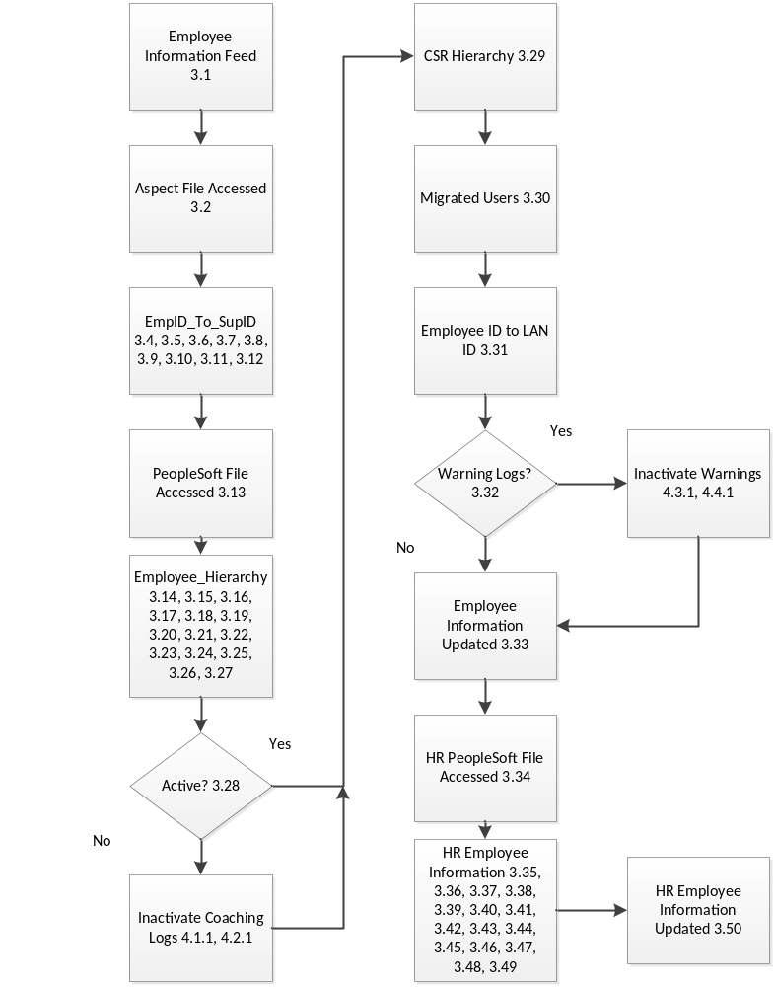
Figure 1 – Employee Data Feed

